SaleManagement

19. januar 2024

15:36

Logical DataModel

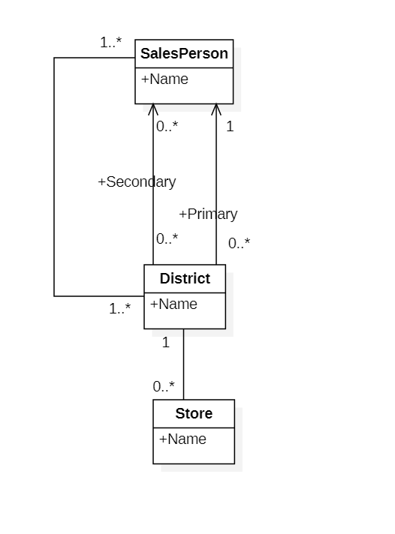

Database design

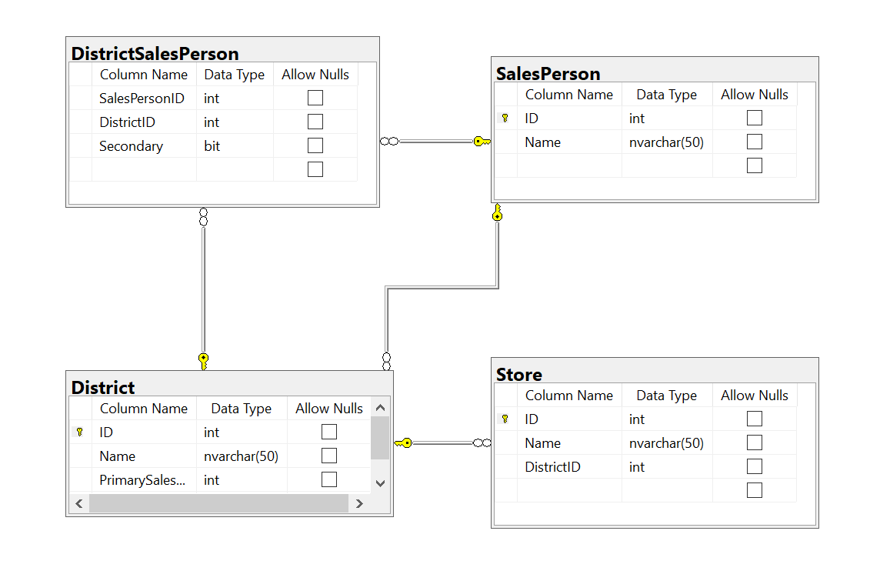

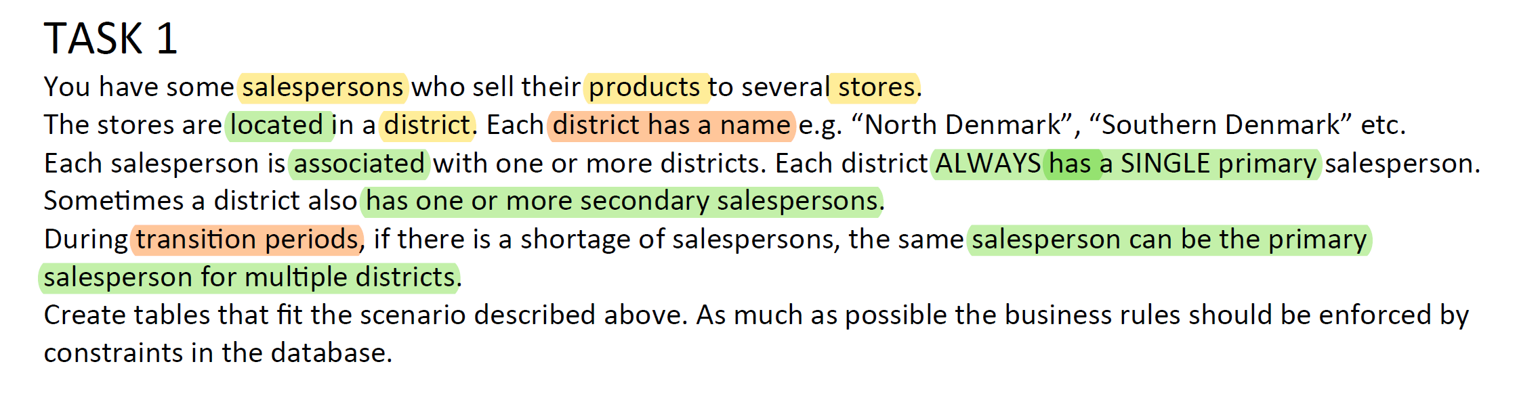

Database Impl

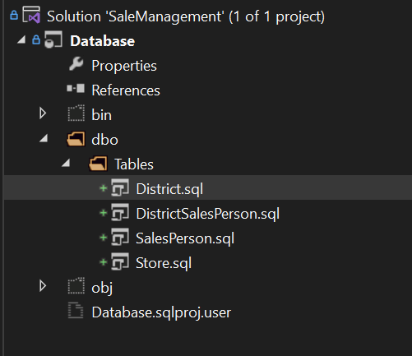

TestData

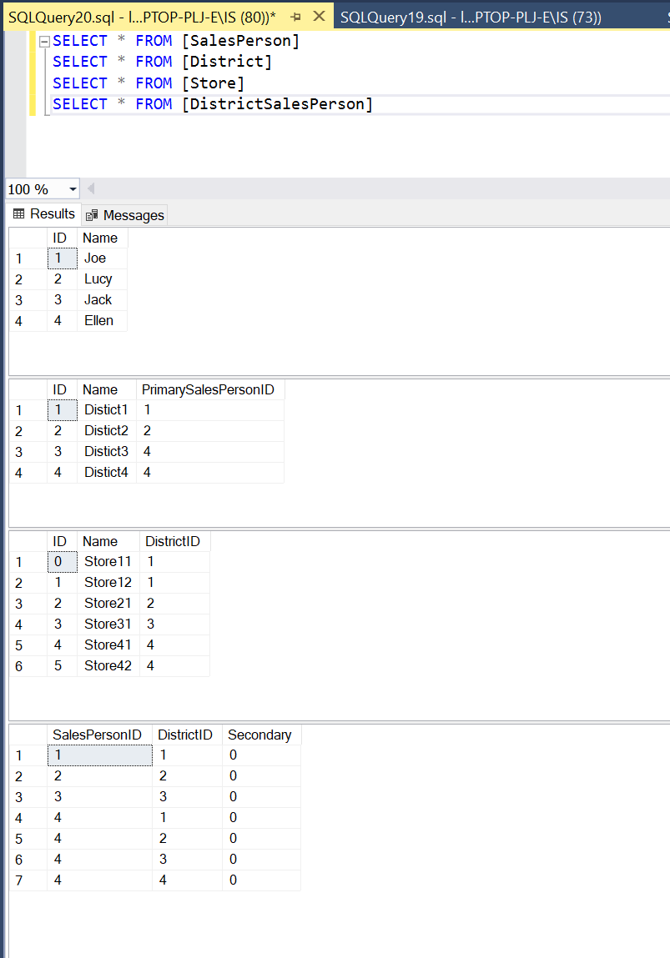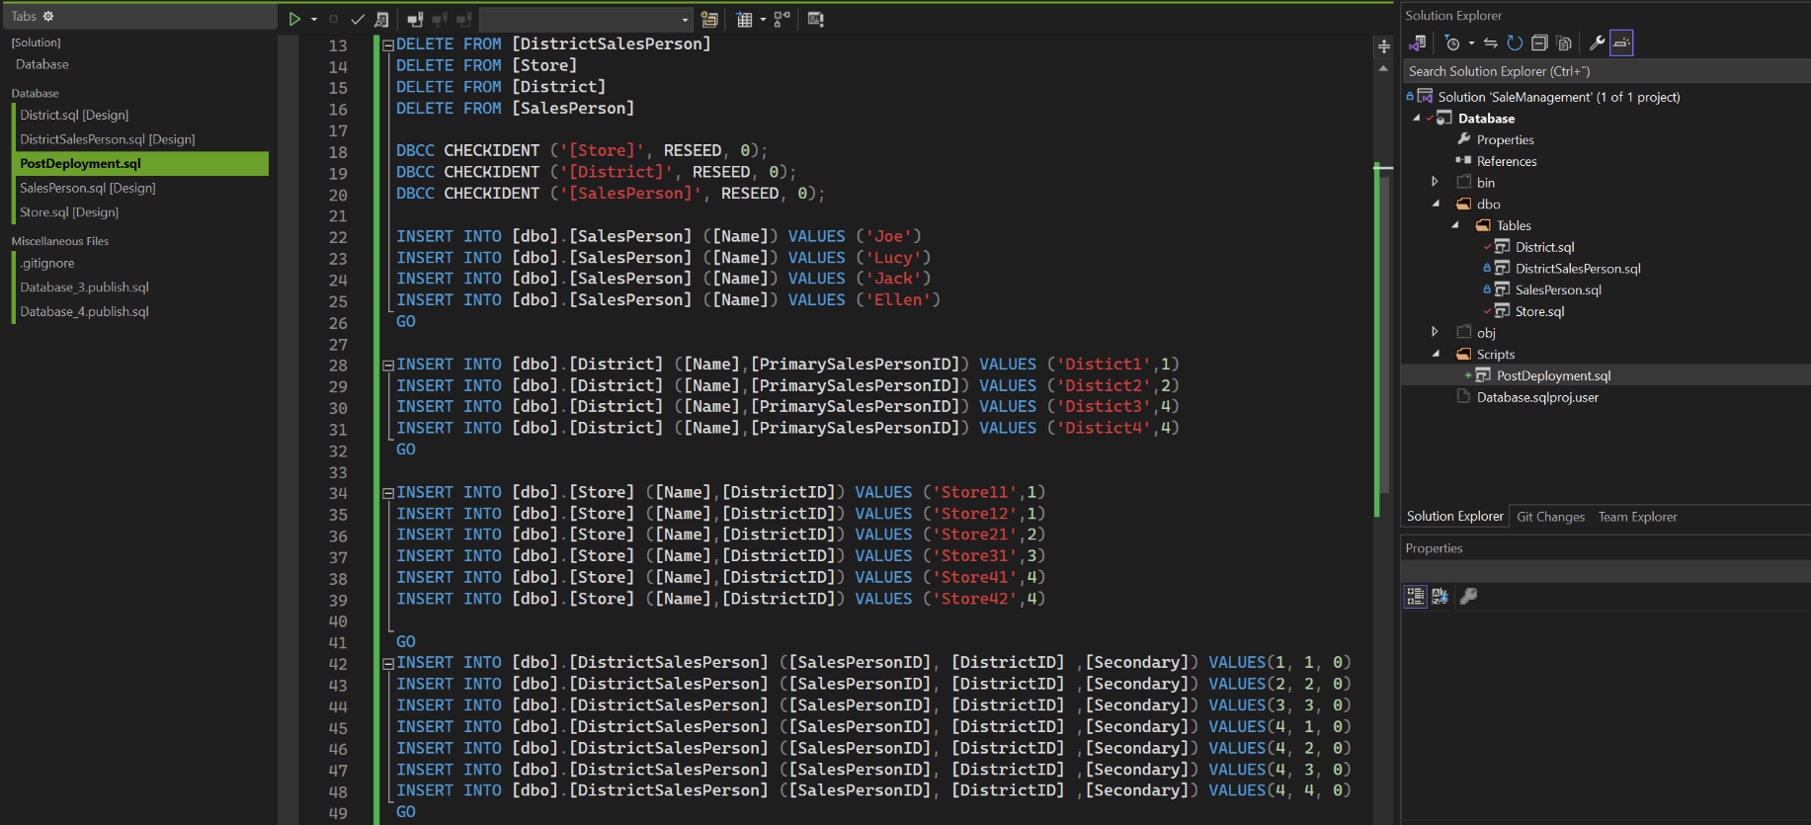

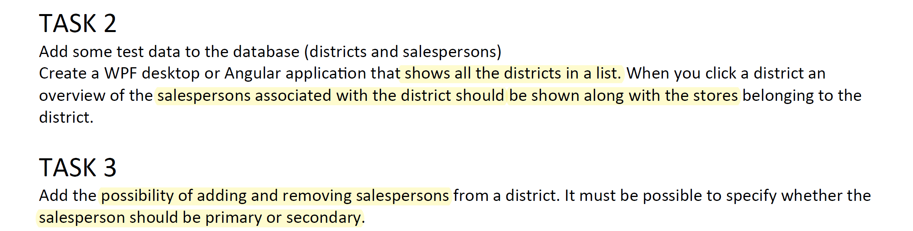

Functionality -> Interface

DistrictDTO[] GetAllDistricts()

DistrictDTO

int Id  
string Name  
SalesPersonDTO[] SalesPersons

StoreDTO[] Stores

SalesPersonDTO  
 int Id  
 string Name  
 bool Primary

bool Secondary

StoreDTO   
 int Id   
 string Name

AddSalesPersonToDistrict(int districtId, int salesPersonID, ResponsibilityEnum? Responsibility=null)

RemoveSalesPersonToDistrict(int districtId, int salesPersonID)

Interface -> Stored proc

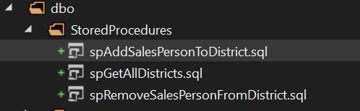

DataAccess Layer + unit test

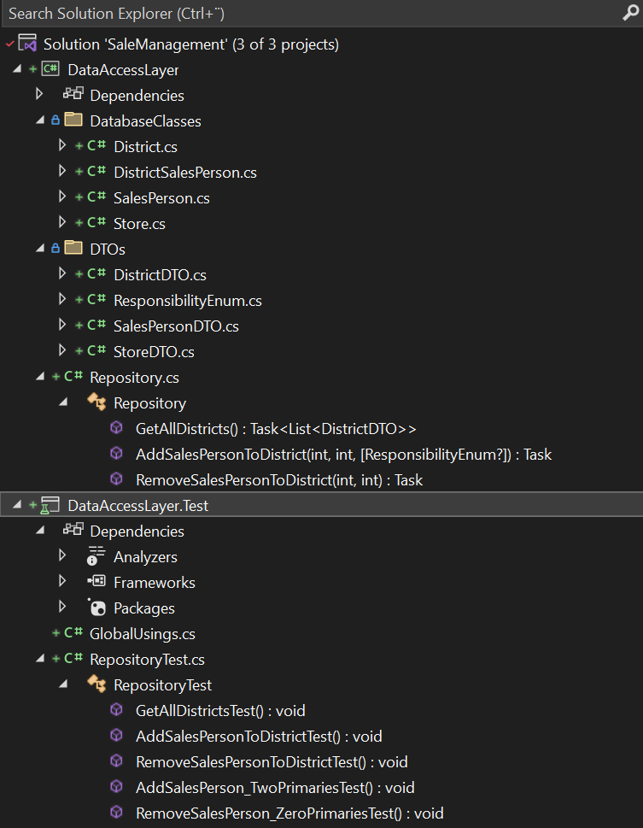

Implementing DAL until unit test pass

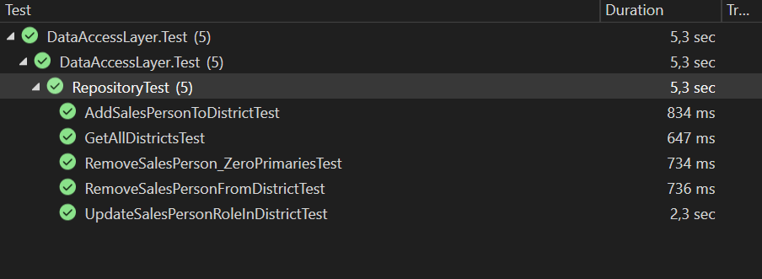

Tilføj webapi

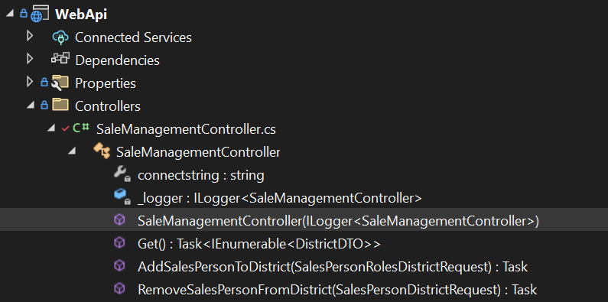

Og WebApi.Client med Nswag

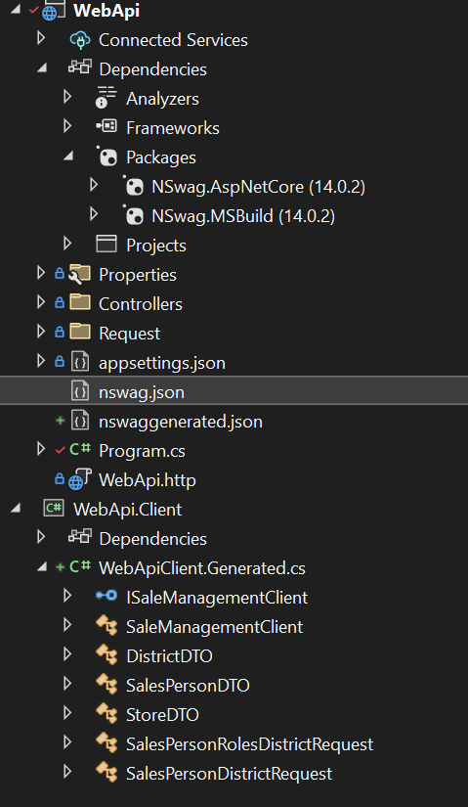

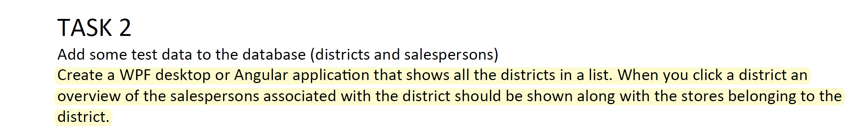

UI Design

Districts Sales persons

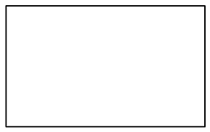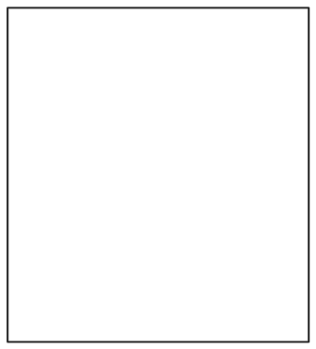

Add

Salesperson listbox



Remove

Stores

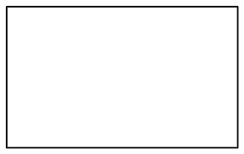

WPF App implemented

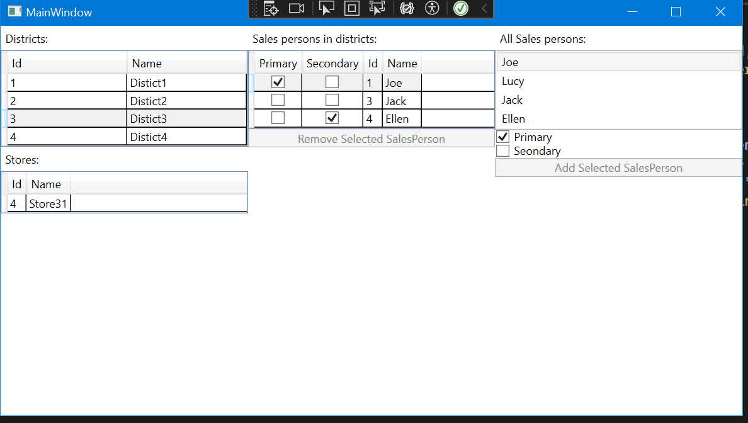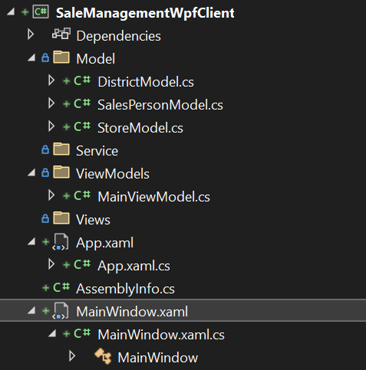

Adding dependency injection wpf client

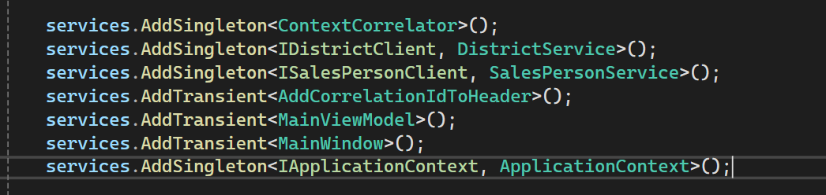

Adding dependency injection web api

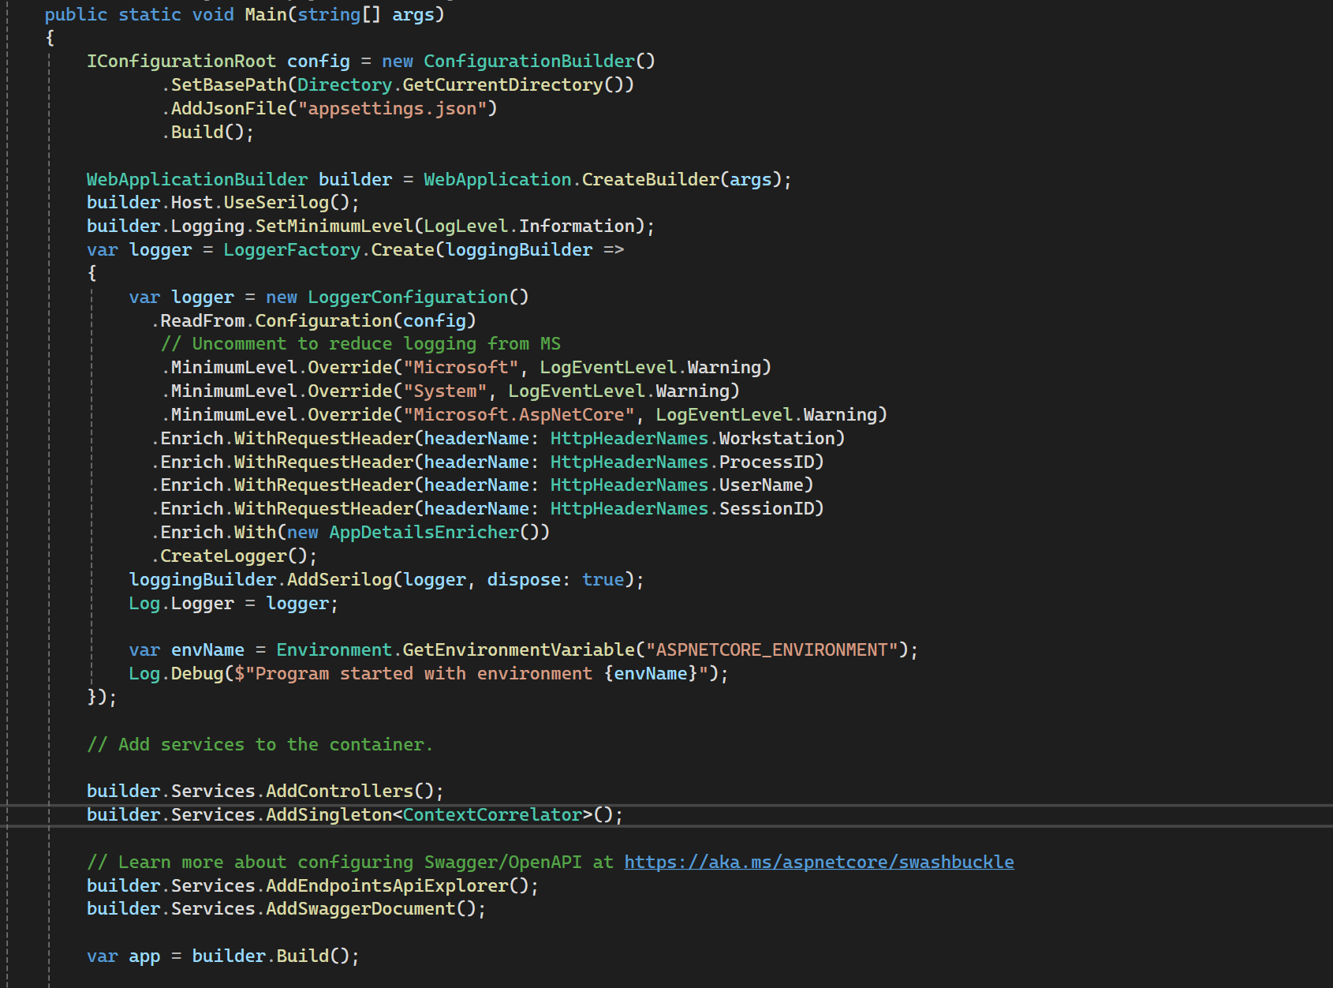

Adding HttpClientFactory



Adding serilog/SEQ + enrichment

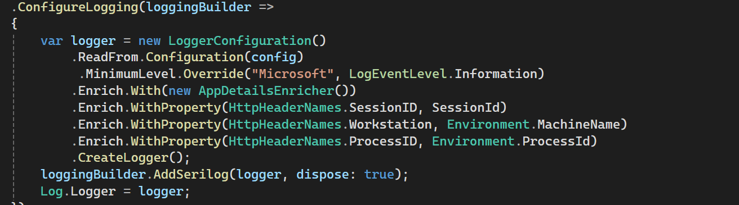

Adding error middleware + correlation ID

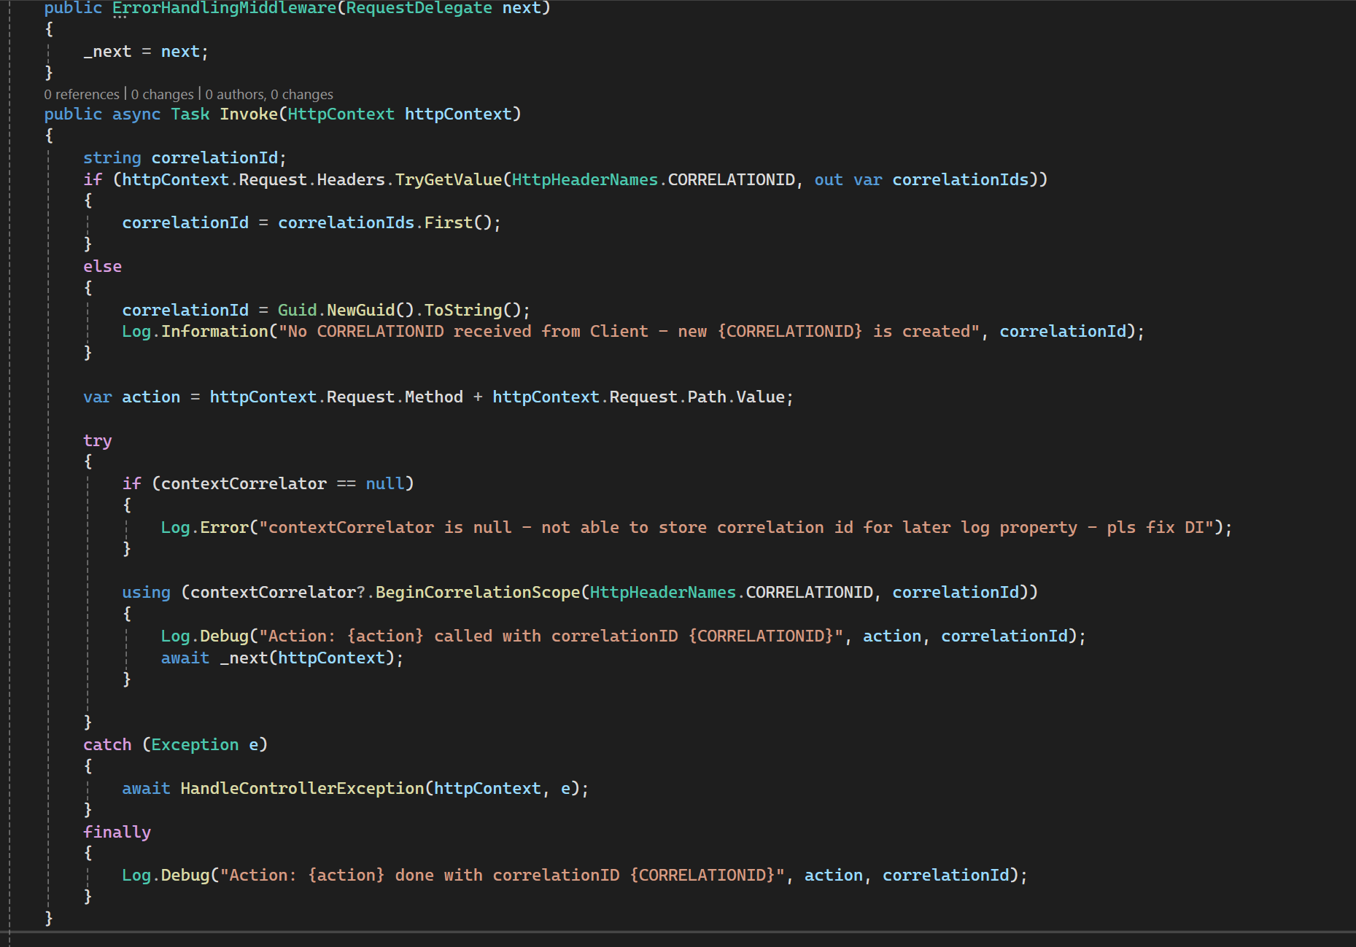

Adding retry handling with Polly

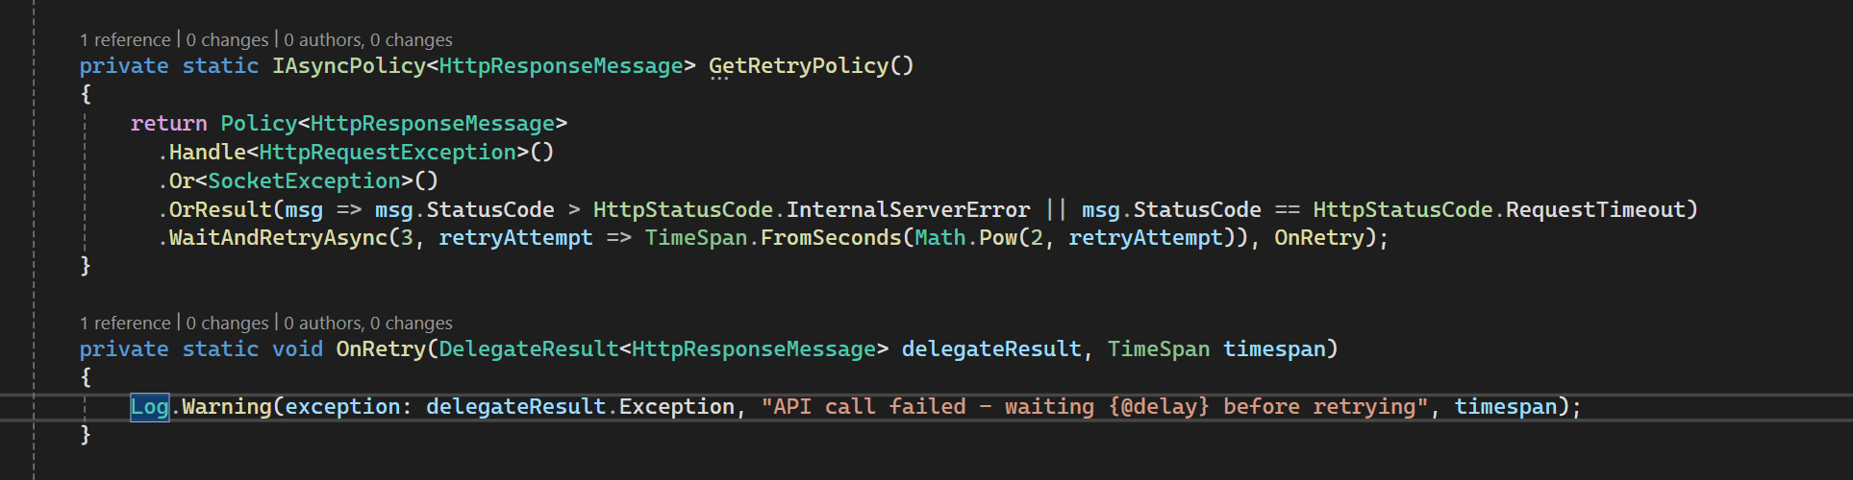

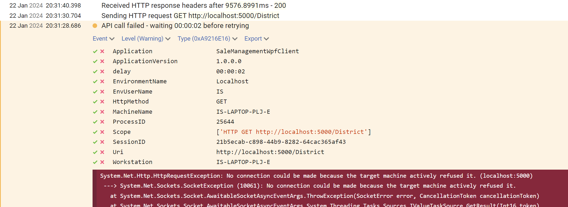

Improving performance of json serialization with precompilation